In SystmOne you can set up a word letter that will use merge fields to automatically populate when writing a letter in your patients record.

This can be set up as a template or you can do it on an ad hoc basis when in a patients record.

To set up a template;

* Select users&policy > Referrals and Letters > New ‘Word’ letter template.

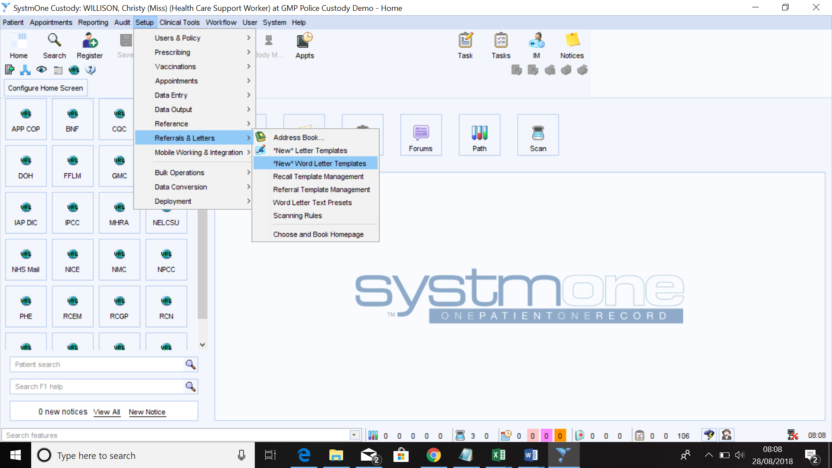

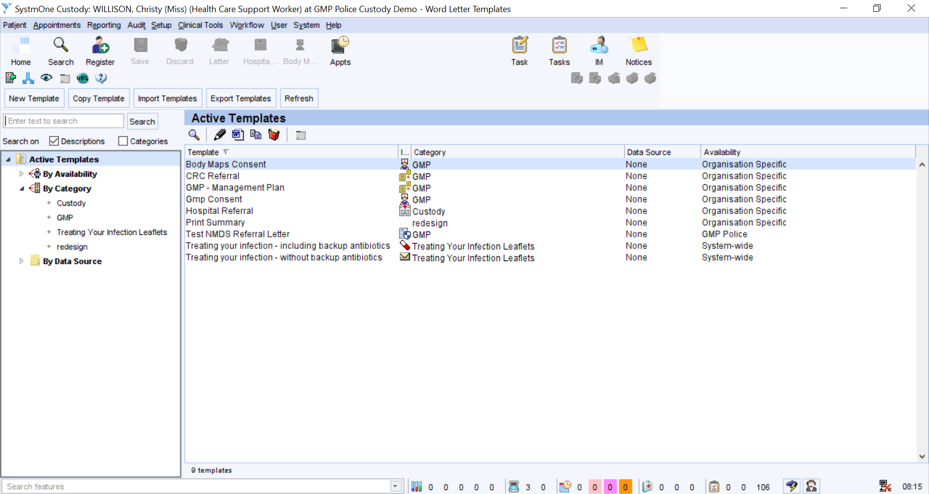

Along the top of the screen there are a few buttons. You can use ‘New’ to create a new template or you can use ‘Copy’ to copy an existing template. For example if you had a standard letter with Recipient and patient details as well as your company letter head you could just copy it to save adding all of those details in again.

When creating a New template we get an option to start our letter with an blank word template or we can import an existing word document, again of you wanted to import your company letter head etc.

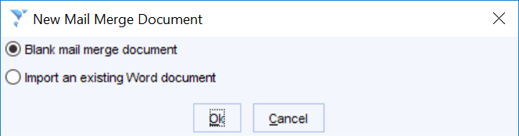

* Select ‘Blank mail merge document’ and select ‘OK’, you can then fill in the following dialog box. You can give the template a name, a description if necessary, put your letter in a category (folder). This will make it easier to find if you ever need to amend it in the future. You can then give your letter an icon and default letter type if needed. The default letter type is assigned to the letter automatically once written in a patients record n.b Letter type can be reported on.
* Click ‘OK’

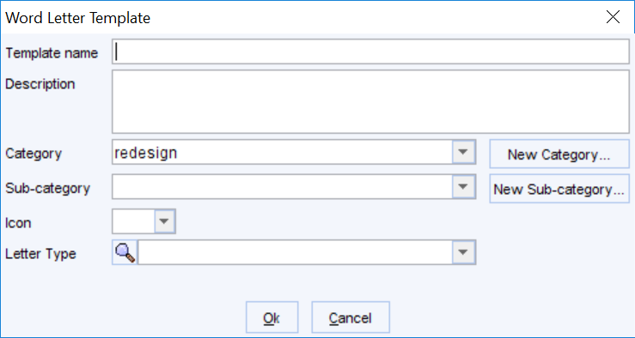

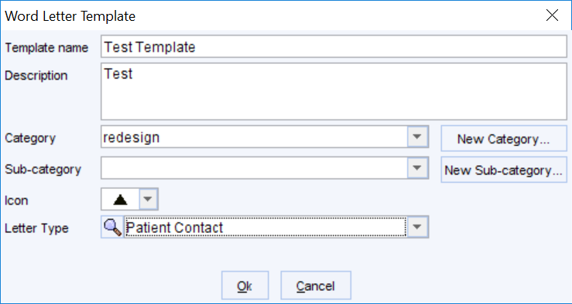

* A blank word document will open, all word functionality is the same so you can use it in the normal way. You will just have an extra tab for SystmOne mail merge.

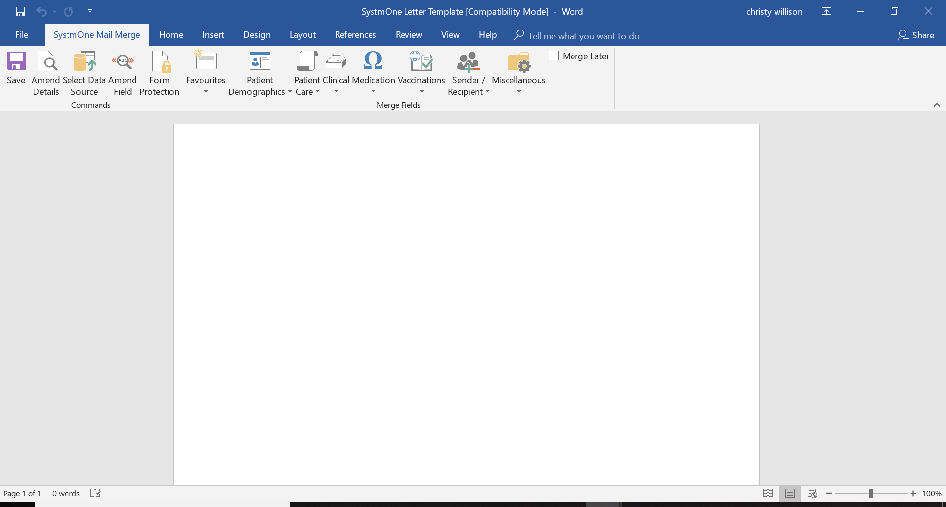

* You can now start to build your letter
* The merge field options live in the icons along the top of the above screen. If I want to merge the patients name I can select ‘demographics’.

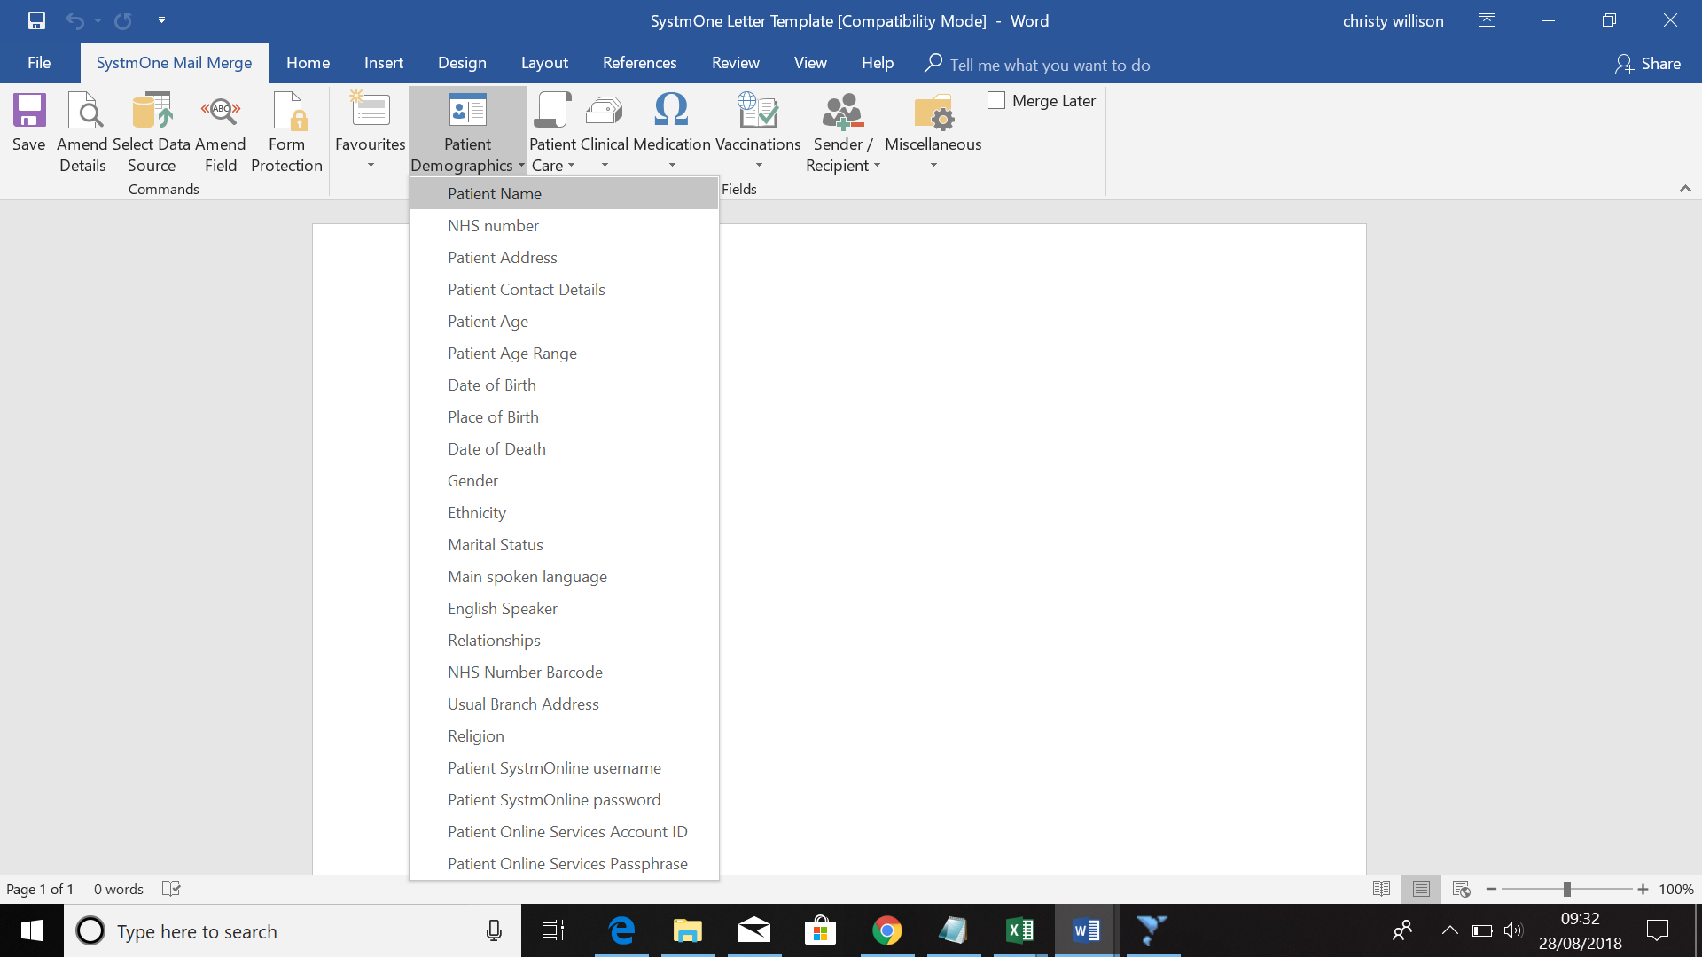

* Once you select patient name you will get the option to select how you want the merge field to ‘Output’.

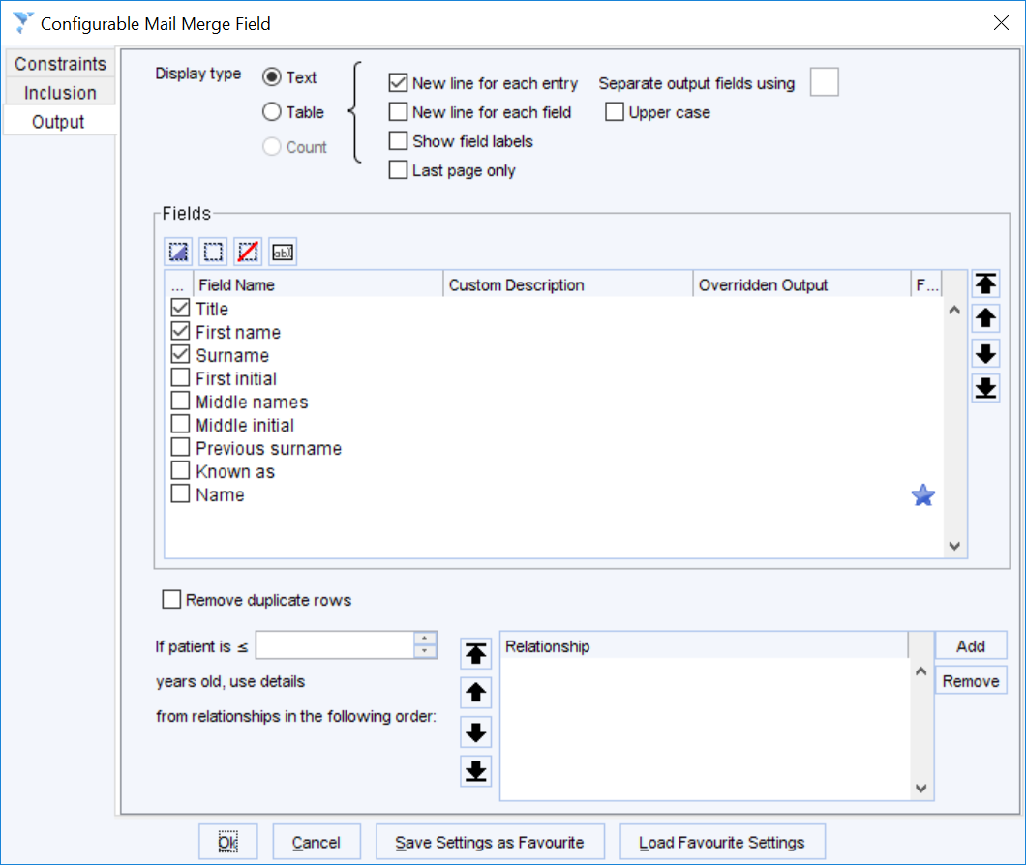

* First of all you can select the ‘Display type’ you can choose between ‘text’ or ‘table’.
* You can then choose how exactly you want to output the patients name by ticking the appropriate box.
* All merge fields have slightly different out put options but the fundamental of using them are the same.
* If you wanted to merge the patients last two temperature readings you would need to use the filter option on the merge field.
* First we need to select the ‘Clinical’ menu and select ‘Numerics’

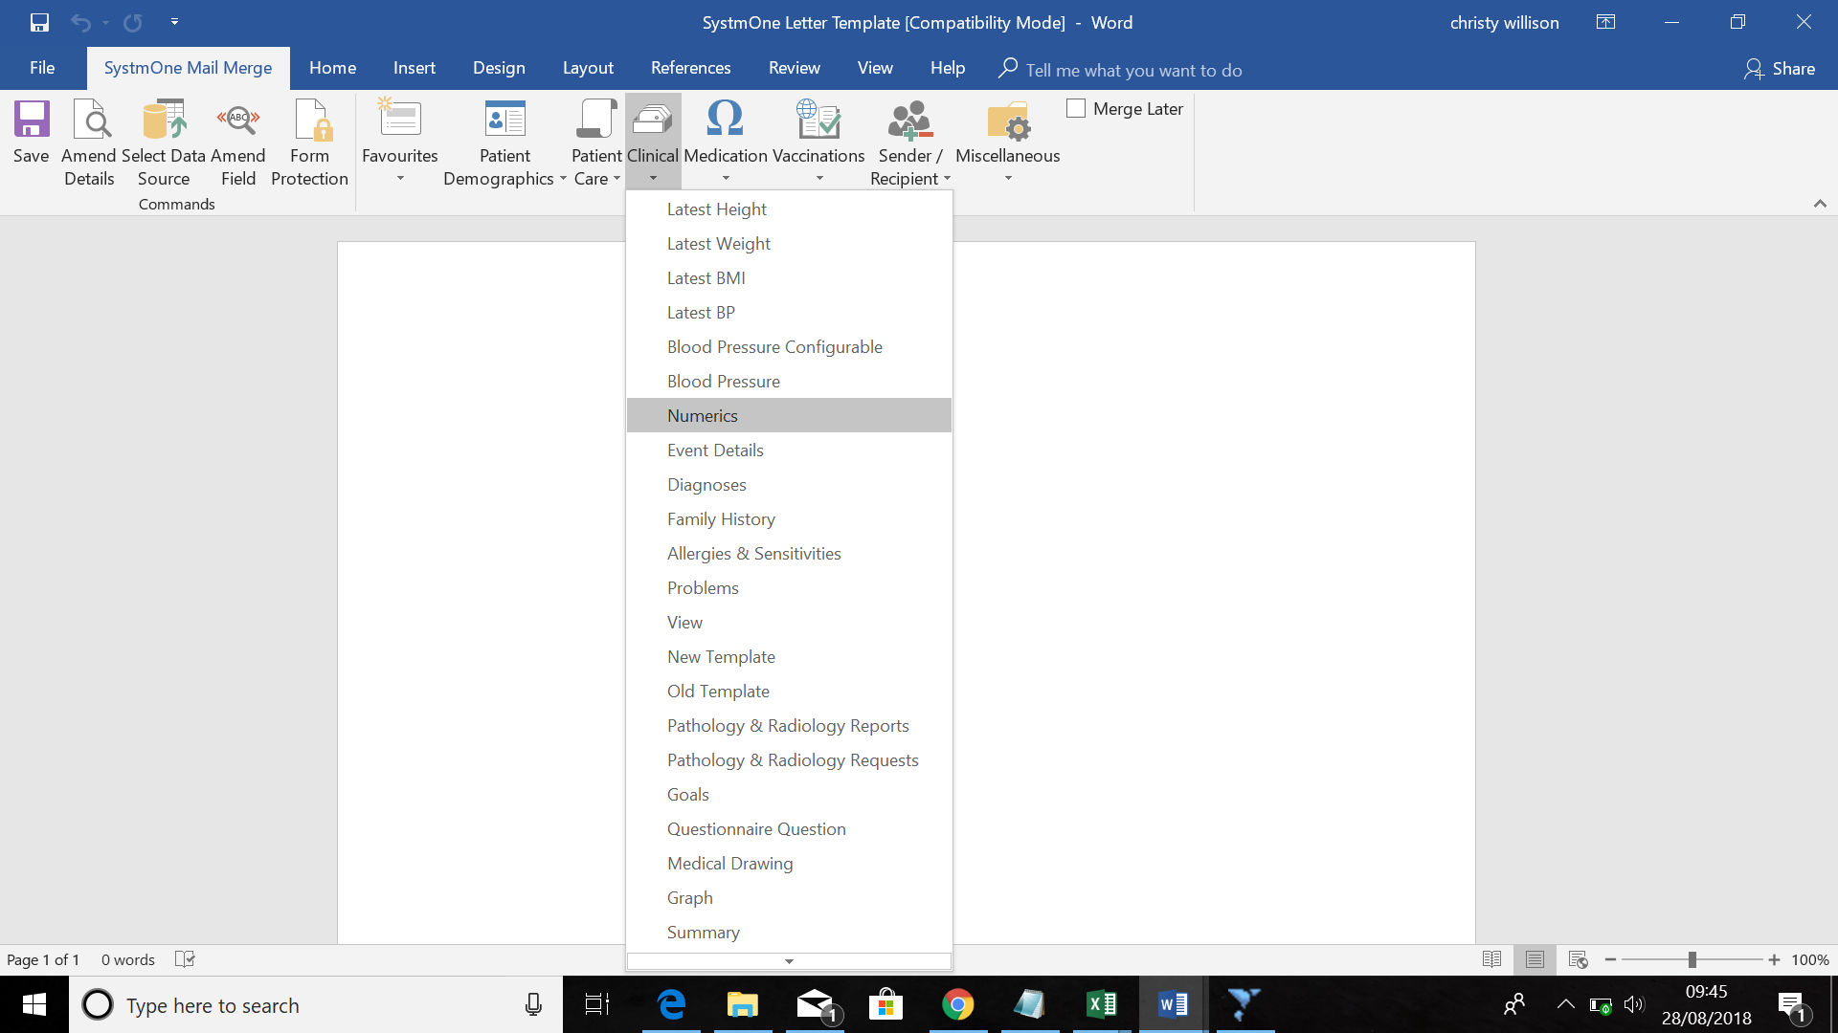

* This time the dialog box will look slightly different but you can choose your output in the same way.

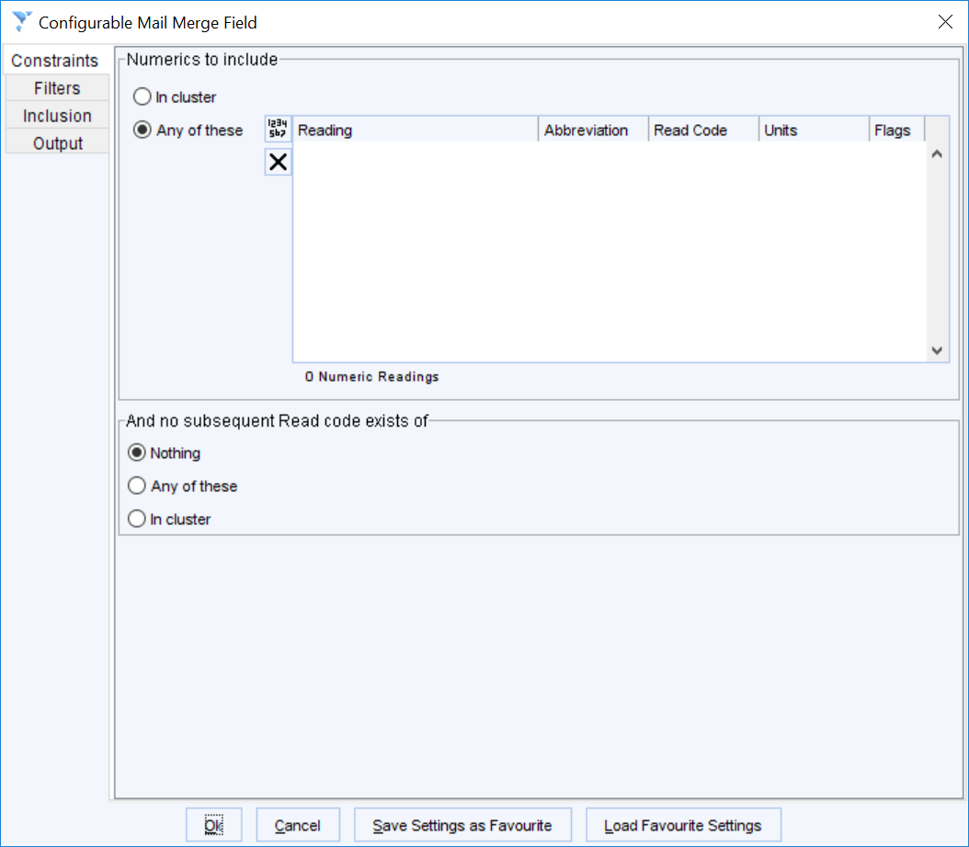

* The first option is ‘Constraints’, this is where you can select your ‘Temperature’ option. Select the button with the small numbers on (this is the icon used for numerics)



* The read code browser will then appear and you can search for temperature and select ‘OK’

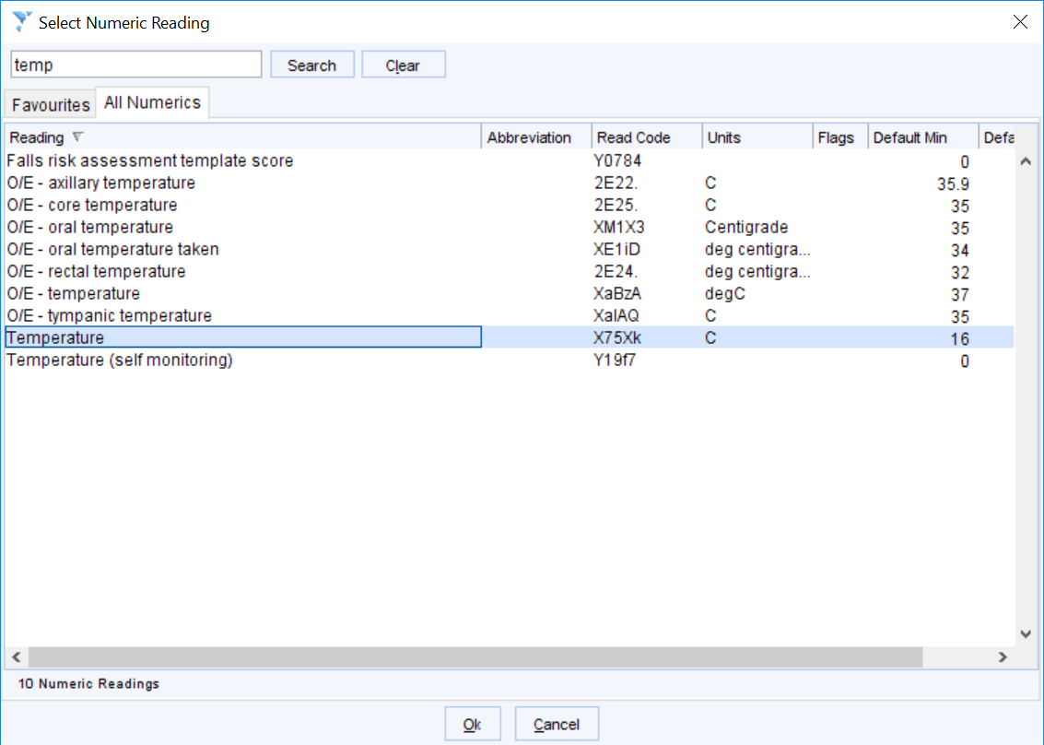

* You can then move down to the ‘filters’ tab and select the relevant option from the drop down box.

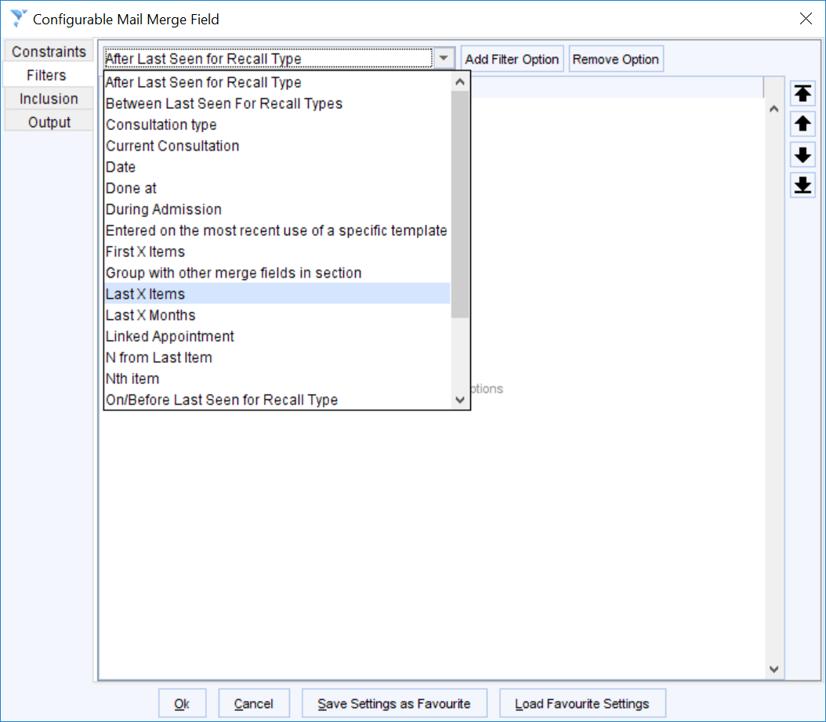

* In this example you want the last two readings so you can select ‘last X items’ and press ‘add filter option’ and change the number to two.

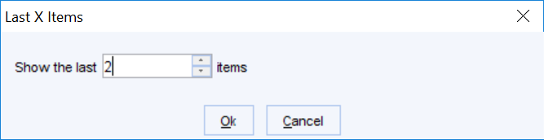

* You can then select ‘output’ and choose how you want the temperature values to display.

